**Red Hat Enterprise Linux 9 installation in VirtualBox**

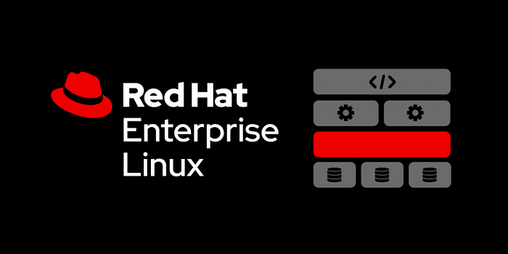

**Red Hat Enterprise Linux**

**Red Hat Enterprise Linux** is a **commercial open source Linux**distribution developed by **Red Hat**for the commercial market.

**Red Hat Enterprise Linux 9 Features**

**Red Hat Enterprise Linux (RHEL) 9** is now generally available (GA). This release is designed to meet the needs of the hybrid cloud environment, and is ready for you to develop and deploy from the edge to the cloud.

**Get access to the latest language runtimes and tools**

* Red Hat Enterprise Linux 9 is built with a number of the **latest runtimes** and **compilers**, including GCC (11.2.1) and updated versions of LLVM (13.0.1), Rust (1.58.1), and Go (1.17.1), enabling developers to modernize their applications.
* Red Hat Enterprise Linux 9 ships with updated versions of core developer toolchains such as GCC (11.2.1), glibc (2.34), and binutils (2.35).
* Red Hat Enterprise Linux 9 improves the **application streams**experience by providing initial application stream versions that can be installed as RPM packages using the traditional yum install command. Developers can select from multiple versions of user-space components as application streams that are easy to update, providing greater flexibility to customize RHEL for their development environment.

**Support for newer versions of language runtimes**

RedHat Enterprise Linux 9 offers the following new versions of dynamic programming languages:

* Python 3.9, Node.js 16, Ruby 3.0.3, Perl 5.32, PHP 8.0

**Build Red Hat Enterprise Linux images for development and testing**

Image builder is a tool that allows users to create custom RHEL system images in a variety of formats for major and minor releases. These images are compatible with major **cloud providers** and **virtualization technologies** popular in the market. This enables users to quickly spin up customized Red Hat Enterprise Linux development environments on local, on-premise, or cloud platforms.

**Monitor and maintain Red Hat Enterprise Linux environments**

* The Red Hat Enterprise Linux 9 web console has an enhanced performance metrics page that helps identify potential causes of high CPU, memory, disk, and network resource usage spikes.
* Red Hat Enterprise Linux 9 also now supports kernel live **patching** via the **web console**.

**Universal Base Images for Building Containers**

* The Red Hat Universal Base Images provide a way to easily build, run and manage container images based on the Red Hat Enterprise Linux software.
* Red Hat Enterprise Linux 9 provides **cgroups** (control groups) and an improved version of podman which is a daemonless engine for building and managing **Open Container Initiative(OCI)** containers on the Linux system.

**Identity and security**

* Red Hat Enterprise Linux 9 provides **OpenSSL 3.0.1**, which is the latest release after the **OpenSSL 3.0** which is the latest LTS release.

**System Requirements**

* 20GB free disk space.
* [**Virtual Box**](https://www.virtualbox.org/wiki/Downloads) on the system.
* RHEL 8 ISO File.
* A minimum of 4 GB RAM is recommended.
* One core or thread for each virtualized CPU and one for the host.

**Step 1 :- Download Red Hat Enterprise Linux 9 ISO**

Proceed to [Red Hat Login Page](https://www.redhat.com/wapps/sso/login.html) and enter the username or email and password to logged in. If you don’t have account create new one and next proceed the process.

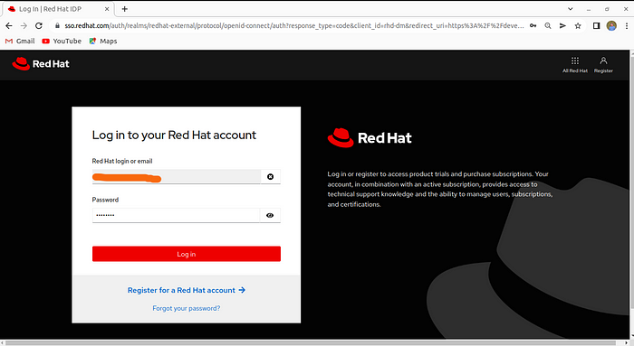

Redhat Login Page

Thereafter, download the [**Red Hat Enterprise Linux 9 ISO file**](https://access.redhat.com/downloads) for free.

Approximate, **Red Hat Enterprise Linux 9 ISO file size** is **8GB**to download.

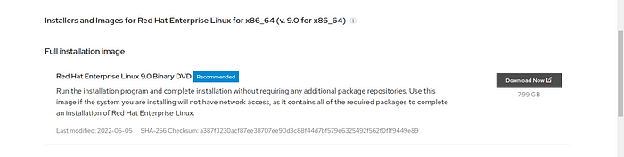

RHEL 9 Download Page

**Step 2:- Create a Virtual Machine**

Lanuch VirtualBox and create a new virtual machine.

Click the**New** icon.

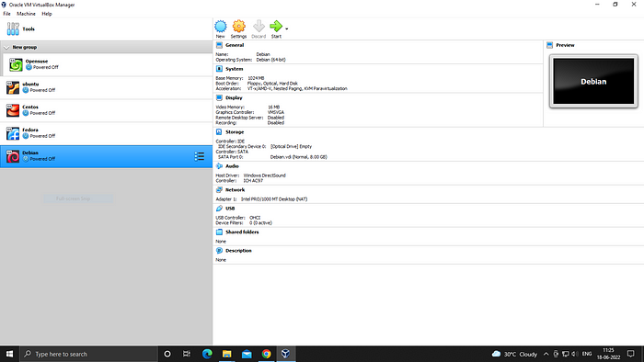

VirtualBox Page

Name the Operating System name.choose Machine Folder, Type and Version.

Click **Next.**

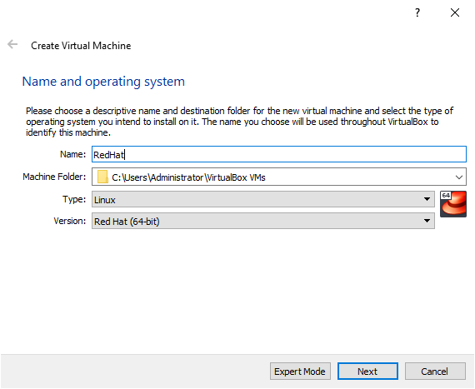

Create Virtual Machine

In the next step, allocate some memory for your virtual machine. In this case, I have chosen to assign a memory capacity of **3099 MB**.

Allocate the **memory size** for operating system.If you find this is too slow, you can change it at any time while the **virtual machine** is shutdown.

Click **Next.**

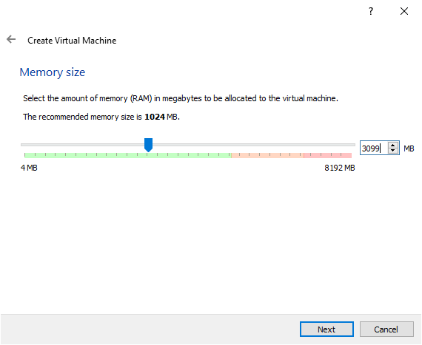

Allocate Memory Size

In the next window, select **Create a virtual hard disk now.**

Click **Create**.

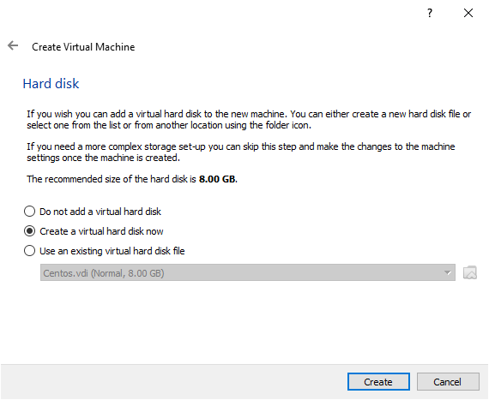

Choose Hard Disk

Select the **VDI(VirtualBox Disk Image)** as your hard drive file type.

Click **Next**.

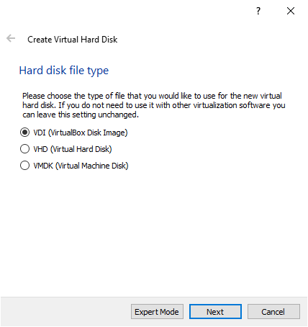

Choose Hard Disk File Type

Choose **Dynamically allocated**, so it can use space on your hard disk as it fills up.

Click **Next**.

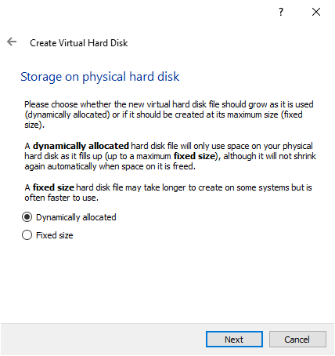

Choose Hard Disk Type

Select File Location and Size.

Choose your Suitable file location and the size of the virtual hard disk. I have chosen to assign **50 GB** to my **virtual machine.**

Click **Next**.

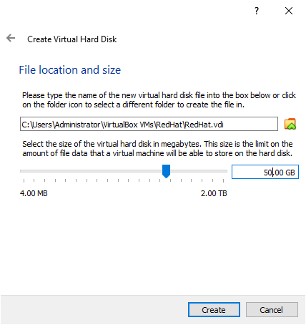

Choose File Location and Size

Now, new virtual machine has been successfully created.

**Step 3:- *Setting Up the Virtual Machine for RHEL 9***

Click **Settings.**

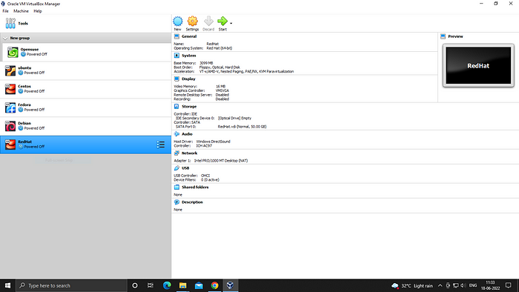

Virtual Machine Page

In the general option, choose Advanced tab.

Here you can choose shared clipboard settings. Select each dropdown menu and choose the **Bidirectional**option to enable the machine’s clipboard sharing and drag-drop features.

It is used to copy and paste some content between the virtual machine and the host.

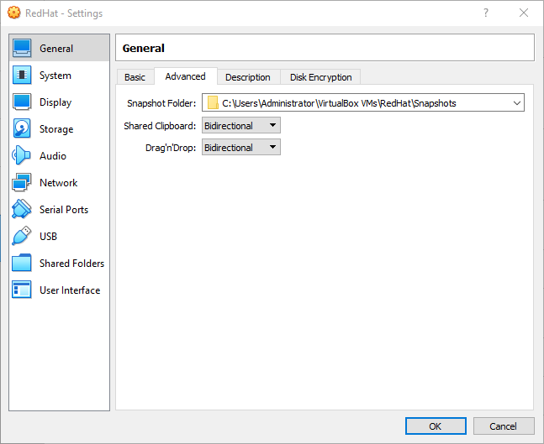

Settings Page

After clicking on the storage, we will attach the Red Hat Enterprise Linux 9 ISO file to our operating system.

Click on the **Empty** under**Controller: IDE**.

After click on **Empty**.

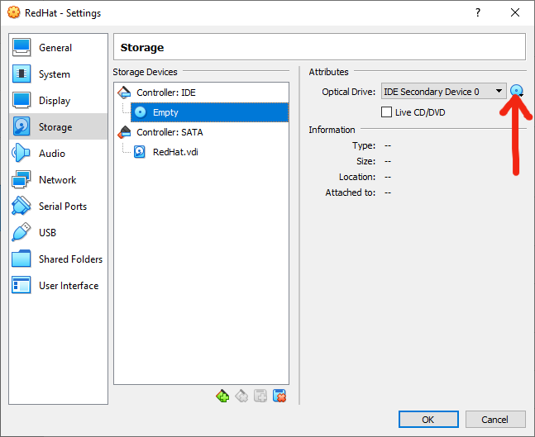

Settings Page

Choose your **Red Hat Enterprise Linux 9 iso image file** in your local system. And then select **Red Hat Enterprise Linux 9 iso image file**, then

Click **Open.**

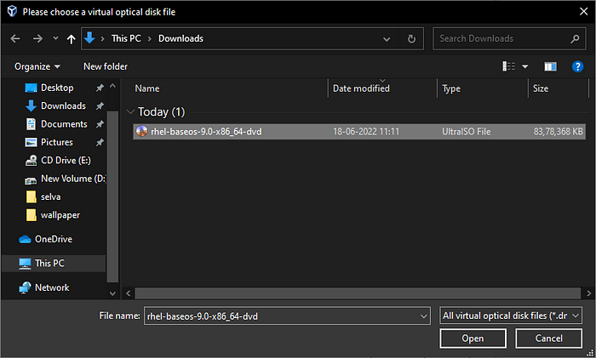

Select ISO File

Now, Red Hat Enterprise Linux 9image file was selected. And then click **Ok.**

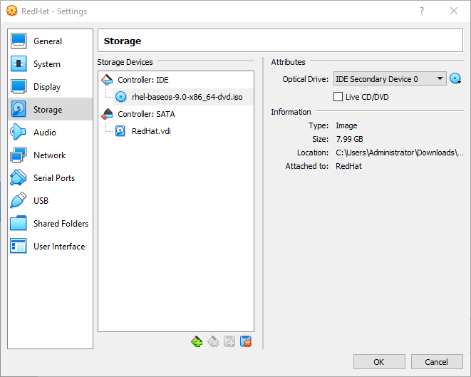

Settings Page

**Step 4:- Installing RHEL 9 in VirtualBox**

Now, let’s boot up our machine and Install Red Hat Enterprise Linux 9.

Click **Start** icon on first screen.

The Red Hat Enterprise Linux 9 installation process will be started.

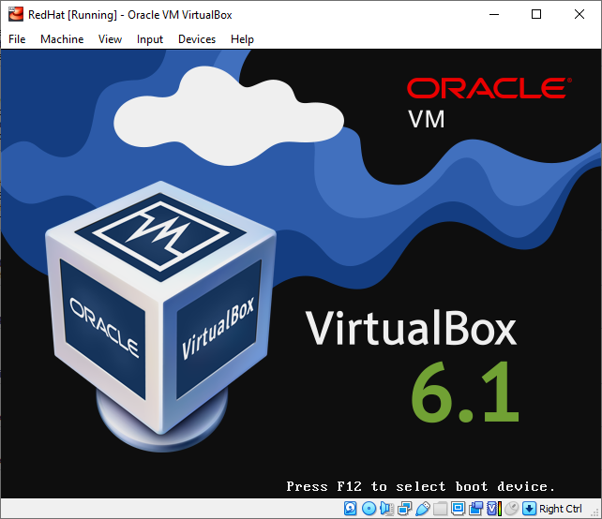

RHEL 9 Installation Started

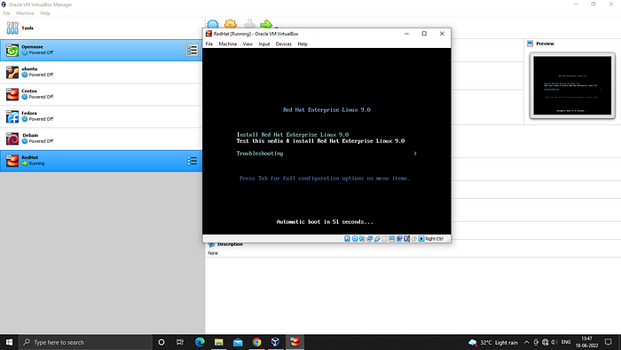

RHEL 9 Boot Menu

Now, use the up and down key to go to Install Red Hat Enterprise Linux 9.

Press **Enter** key.

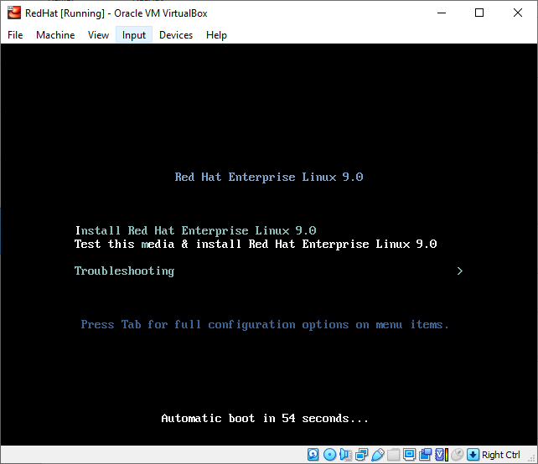

RHEL 9 Boot Menu

Red Hat Enterprise Linux 9 is booted and testing the process. After, the window below will prompt you to select the installation language.

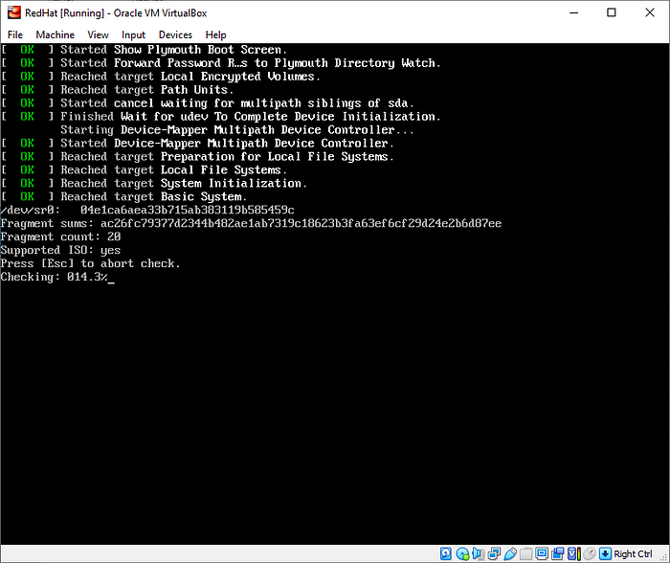

RHEL 9 Booting

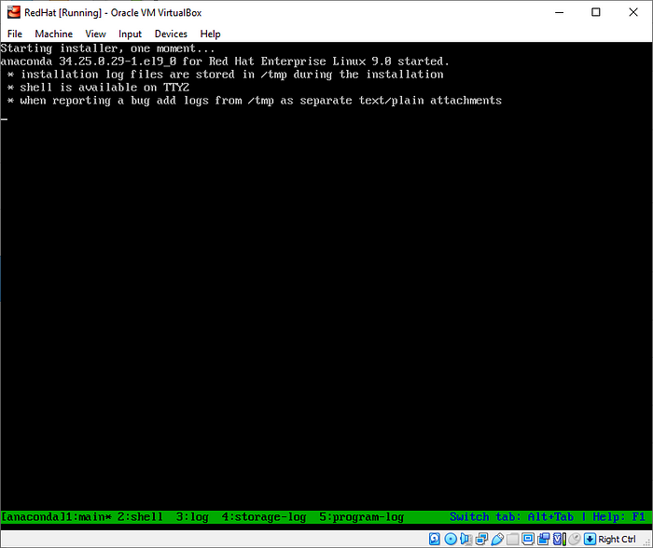

RHEL 9 Booting

Now, you should select your preferred language. I’m using **English**.

And press **Continue.**

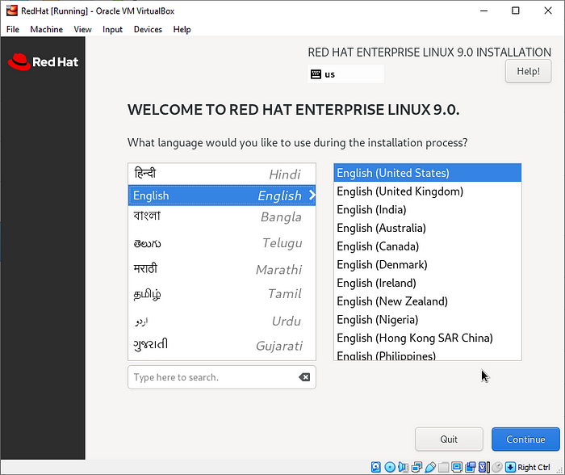

RHEL 9 Language

Now, should setup the **Installation summary**.

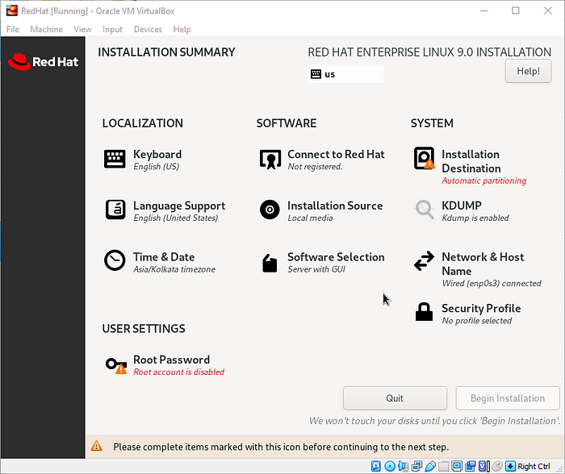

RHEL 9 Configuration

**Localization**

**Keyboard**

Now, should add your preferable **keyboard layout**.

click [ + ] symbol to add**keyboard layout** and [ - ] symbol to remove**keyboard layout**.

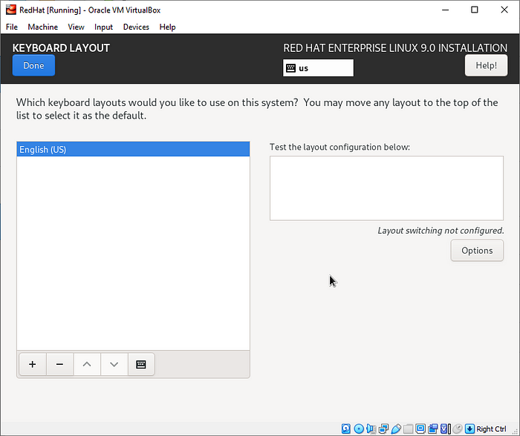

RHEL 9 Keyboard Layout

In my case, I choose **English (India, with rupee)**.

Click **Add**.

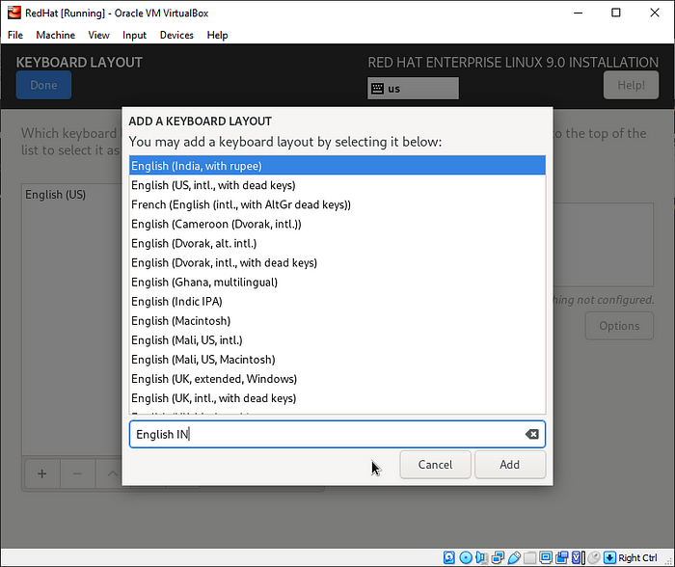

RHEL 9 Keyboard Layout

I selected my **keyboard layout** and also my overview the **keyboard layout**.

Click **Done**.

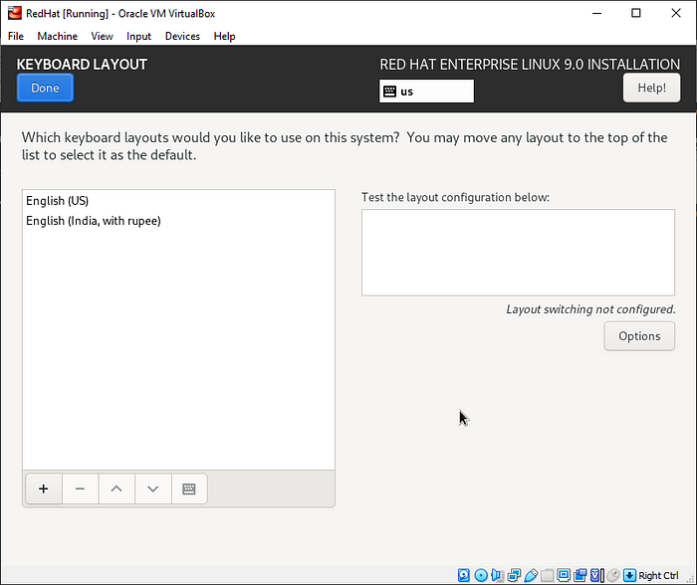

RHEL 9 Keyboard Layout

**Language Support**

Now should select your preferable **language support**.

In my case, I was select additionally **English(India)**.

Click **Done**.

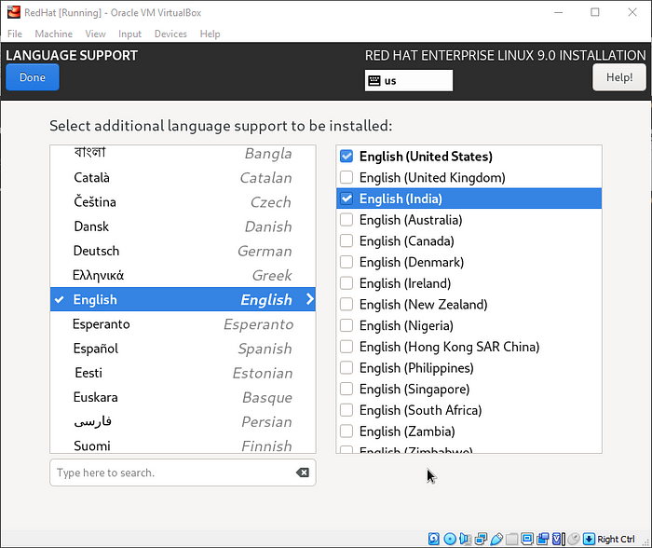

RHEL 9 Language Support

**Time and Date**

Choose the location as per your setup .In my case Region: Asia and City : Kolkata.

Click **Done.**

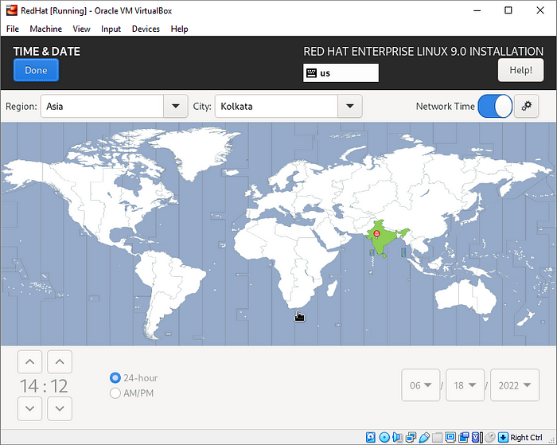

RHEL 9 Time and Date

**Software**

**Connect to Red Hat**

To Connect to Red Hatusing authenticate with your **Red Hat login credentials** like **Red Hat Username** and **Red Hat Password** and **Register** it.

Click **Done**.

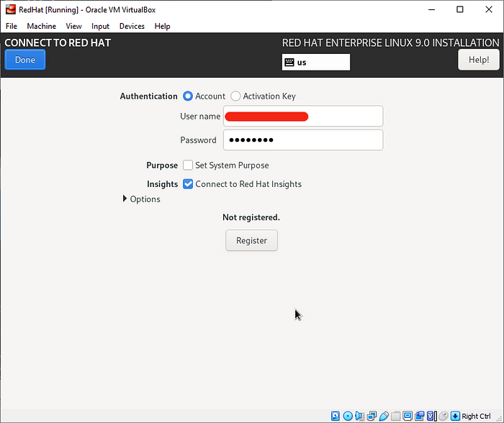

Register RHEL 9

**Installation Source**

To specify a file or a location to install Red Hat Enterprise Linux from, select **Installation Source** from the **Installation Summary** screen. On this screen, you can choose between locally available installation media, such as a DVD or an ISO file, or a network location.

In my case, I choose default **Auto-detected installation media**option.

Click **Done**.

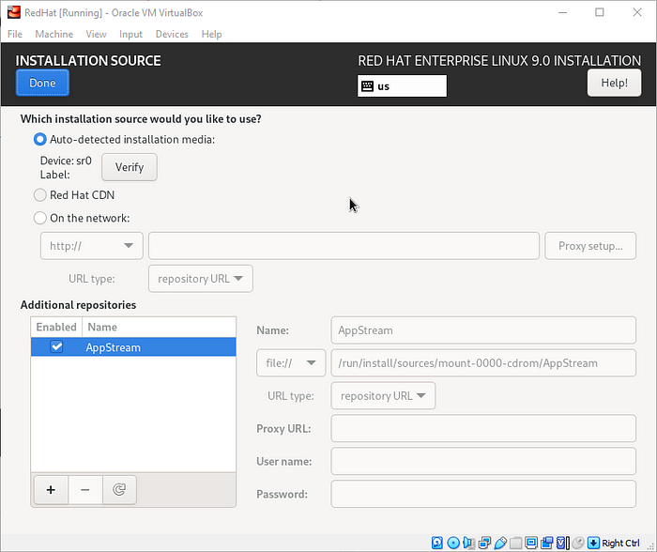

RHEL 9 Installation Source

**Software Selection**

The common installation types are:

* **Minimal Install :**Minimal Server without GUI, for advanced Linux Sysadmins.
* **Workstation** : For installation on Laptops and PCs.
* **Server with GUI:**Server installation with Graphical interface for administration.

In my case, I choose **Workstation**andalso select**Additional software for Selected Environment.**

Click **Done**.

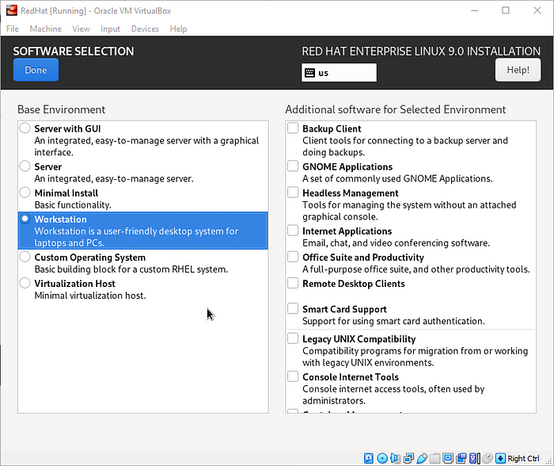

RHEL 9 Software Selection

**System**

**Installation Destination**

In the**Installation Destination,**to select**Automatic**option to create automatically partition the hard drive. Otherwise, select **Custom** option to manually create the partitions.

To ensure the partition option and selected the hard disk .

Click **Done.**

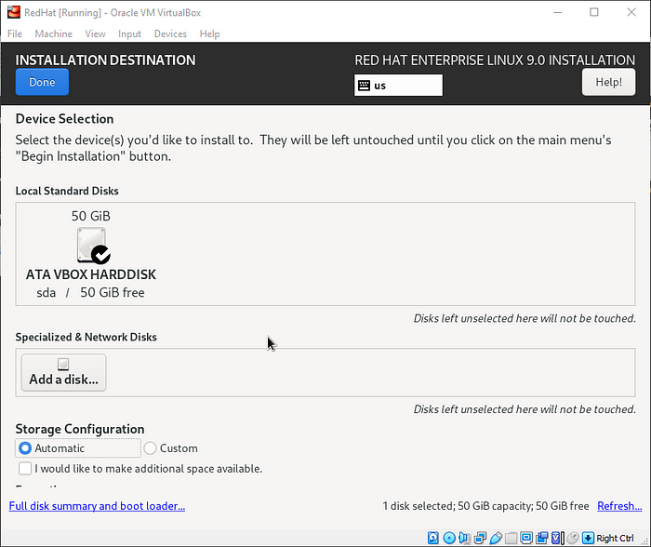

RHEL 9 Installation Drive

In my case, I was select **Custom** option to manually create the partitions.

Click **Done**.

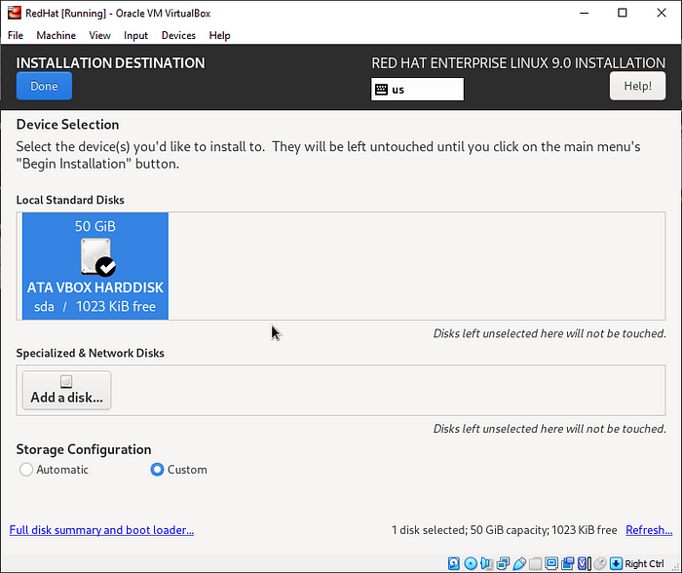

RHEL 9 Install Drive

Now, In the manual partitioning screen. By default, the **LVM** partitioning scheme is selected.

To creating the partitions, click on the [ + ]symbol and to deleting the partitions, click on the [ - ]symbol.

I will create the following partitions on **50 GB disk**.

/boot - 1024MB  
/root - 45GB  
swap - 4GB

You will create partitions based on your purposes and disk size.

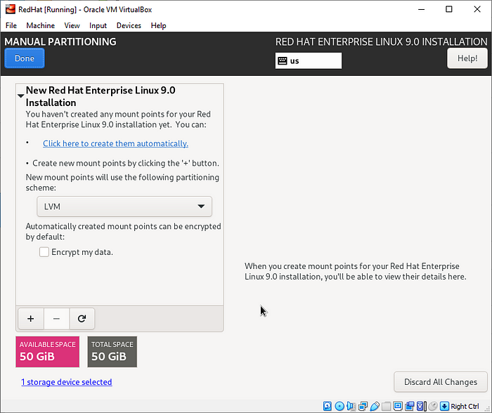

RHEL 9 Manual Partitioning

**Boot partition**

click on the [ + ]symbol .

specify the mount point as **/boot** and size as **1024 MB**.

Click **Add mount point**.

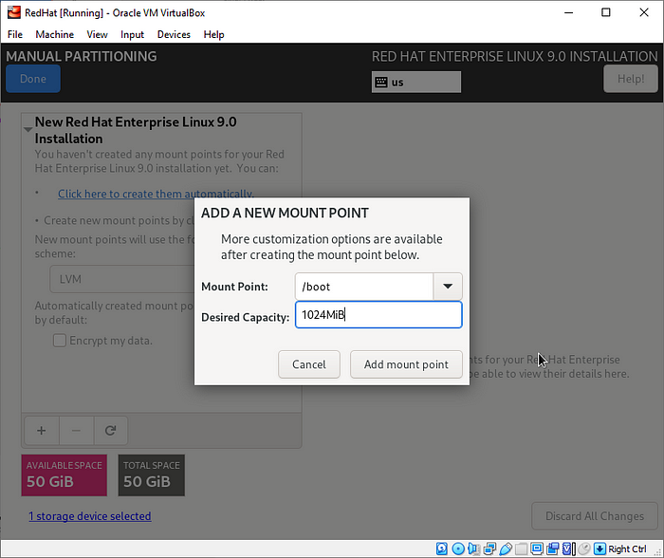

Create Boot Partition

From the partition table below, you can see that the /**boot** partition has been created. Overview the **/boot** partition.

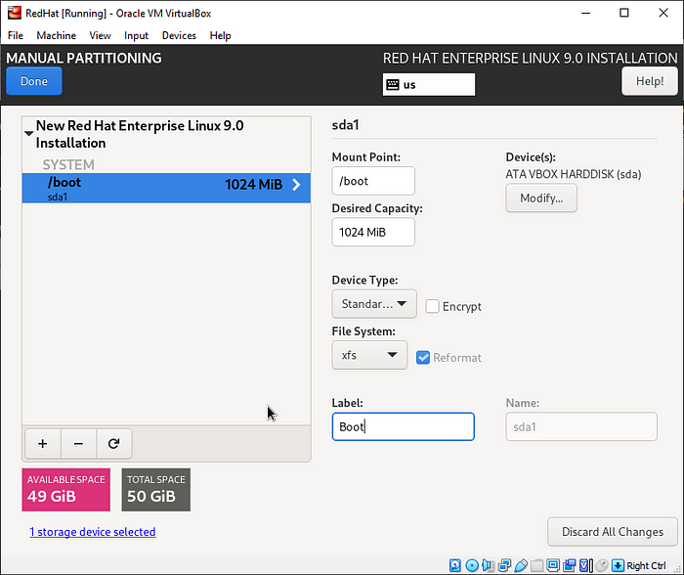

RHEL 9 Partition Table

**Root partition**

Click on the [ + ]symbol.

Specify the mount point as **/root** and size as **45 GB**.

Click **Add mount point**.

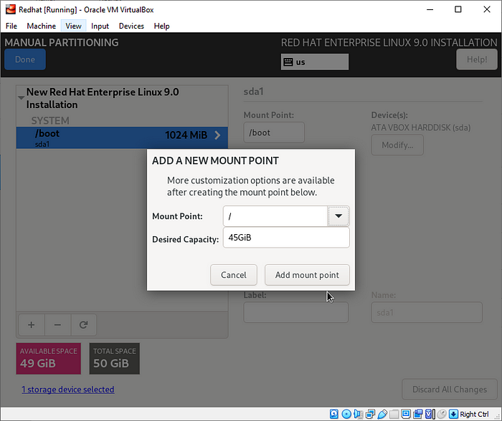

Create Root Partition

From the partition table below, you can see that the **/root** partition has been created. Overview the **/root** partition.

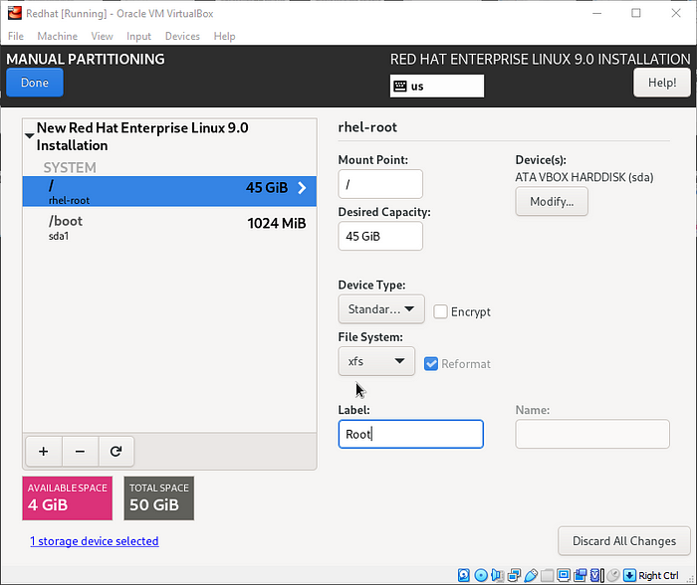

RHEL 9 Partition Table

**Swap partition**

Click on the [ + ]symbol.

Specify the mount point as **swap** and size as **4 GB**.

Click **Add mount point**.

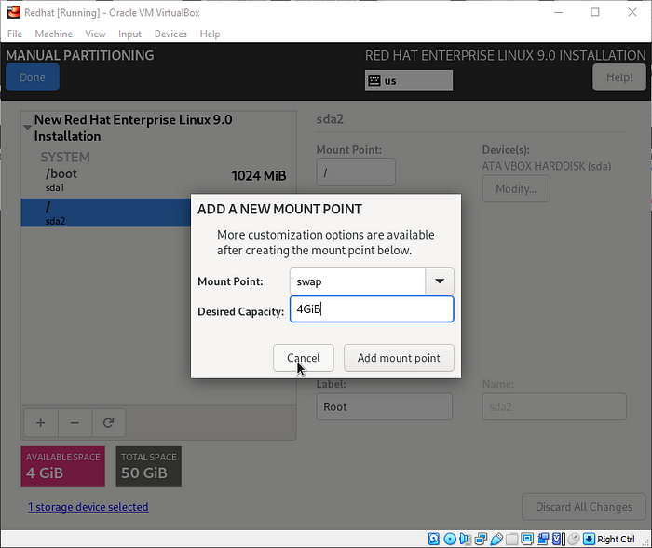

Create Swap Partition

From the partition table below, you can see that the **swap** partition has been created. Overview the **swap** partition.

Now, **/boot**,**/root**, **swap**partitions are created.

Click **Done.**

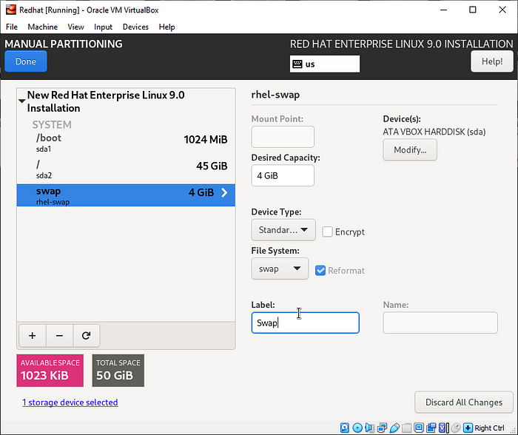

RHEL 9 Partition Table

Overview the **SUMMARY OF CHANGES**.

Click **Accept Changes**.

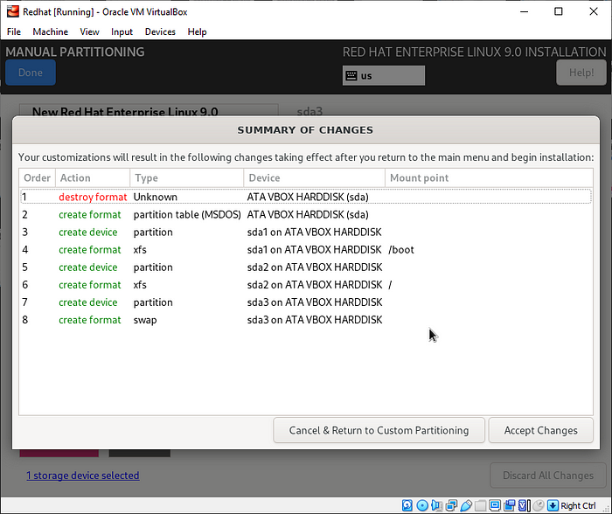

RHEL 9 Disk Changes

**KDUMP**

kdump is **a feature of the Linux kernel that creates crash dumps in the event of a kernel crash**. When triggered, kdump exports a memory image that can be analyzed for the purposes of debugging and determining the cause of a crash.

If you will unchecked the **Enable kdump,** you can save memory.

In my case, I was choose **Enable kdump**by default.

Click **Done**.

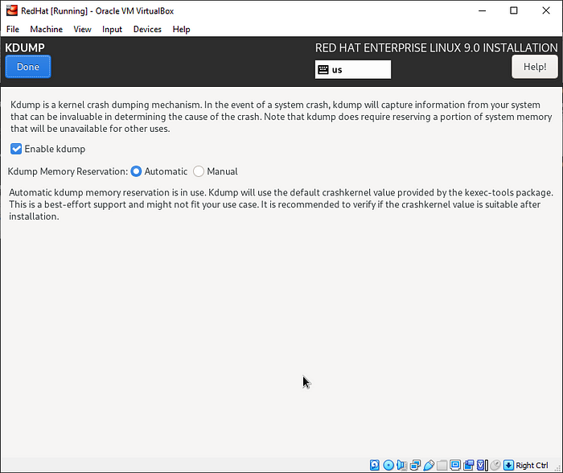

RHEL 9 KDUMP

**Network and Hostname**

In the **Network and Hostname**section, turn on the toggle in the network interface. Setting host Name is optional.

In my case, I choose default network. If you can change network connection, you can configure it.

Click **Done.**

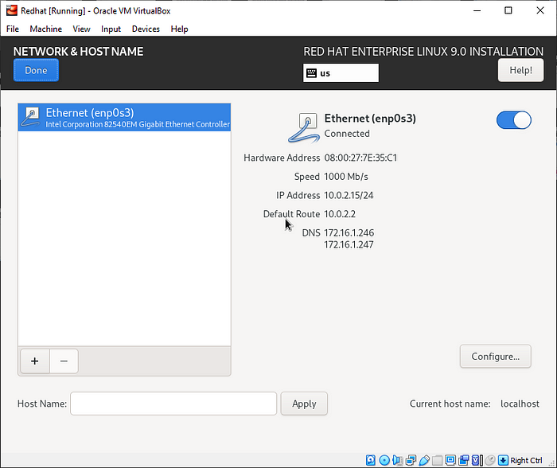

RHEL 9 Network and Hostname

**Security Profile**

**Security profile**you can choose the security policy for your system.

In my case, I was choose **Security profile**by default.

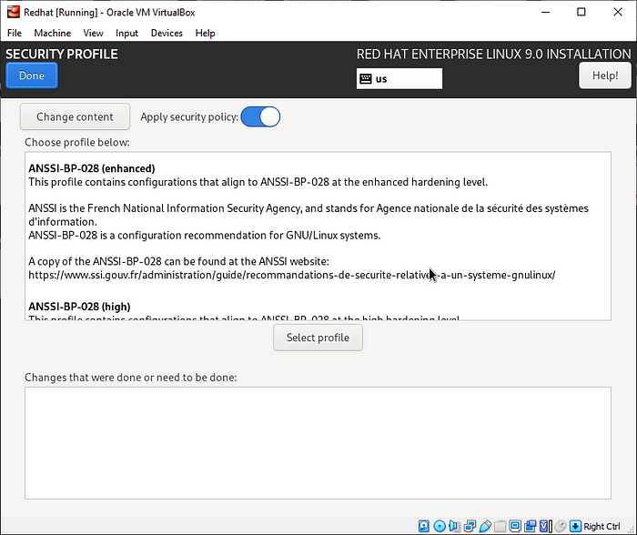

RHEL 9 Security Profile

**User Settings**

**Root password**

In the root account, enter the **Root Password** and **Confirm Password**.

Also your preference to choose **Lock root account** and **Allow root SSH login with password**.

Click **Done** twice.

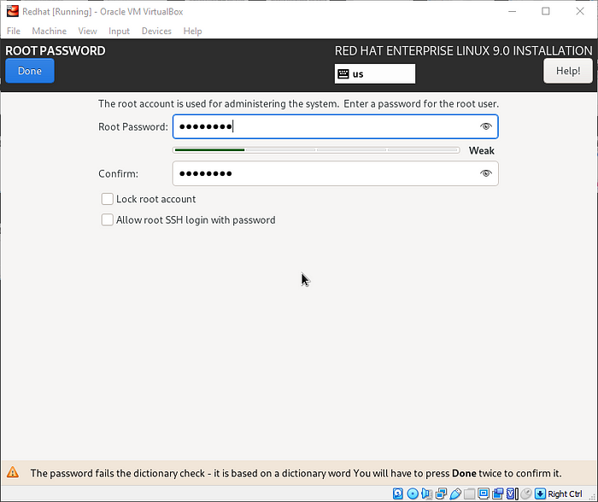

Create RHEL 9 Root Password

**User Creation**

In the user creation, you can set up your user account .

* Enter your name.
* Enter your user name.
* Pick your username.
* Pick your password and confirm password.

Also your preference to choose **Make this user administrator** and **Require a password to use this account.**

Click **Done**.

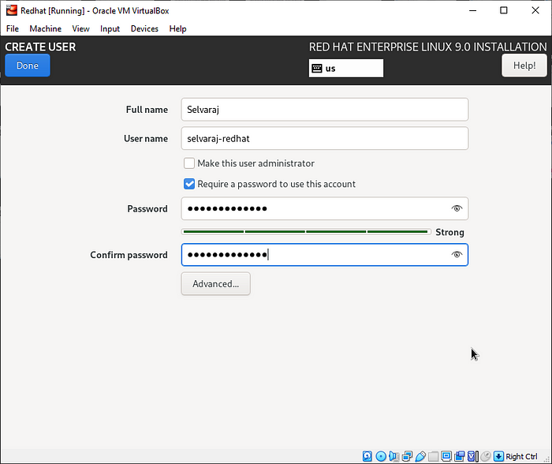

Create RHEL 9 User Account

Now, this **Installation Summary** should ready for the **Begin Installation**.

Once again, overview all things.

Click **Begin Installation.**

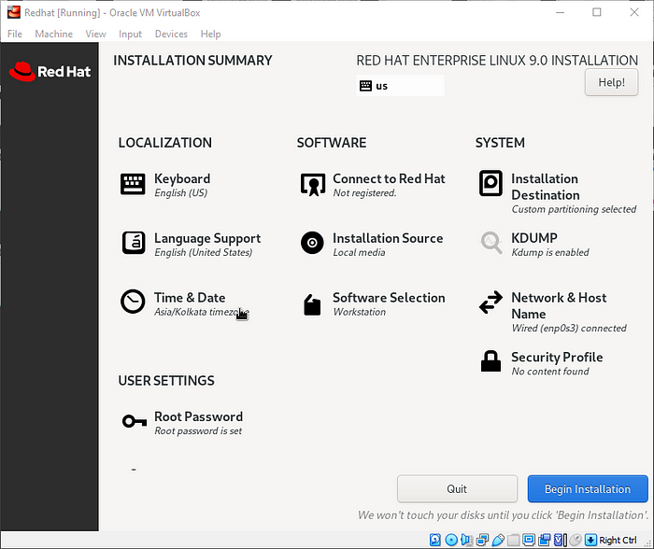

RHEL 9 Begin Installation

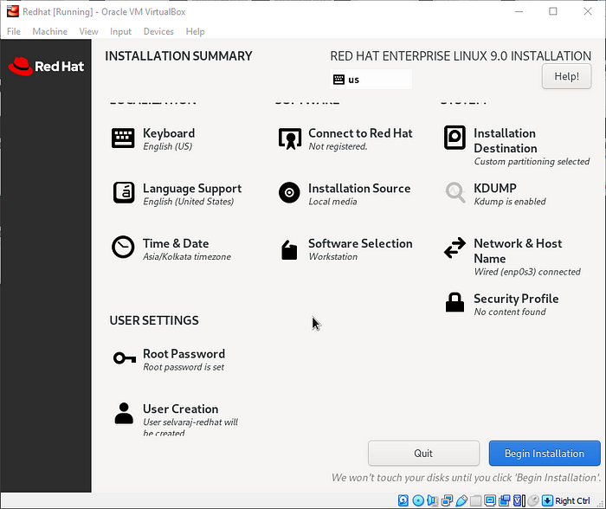

RHEL 9 Begin Installation

**Red Hat Enterprise Linux 9** Installation is processing.

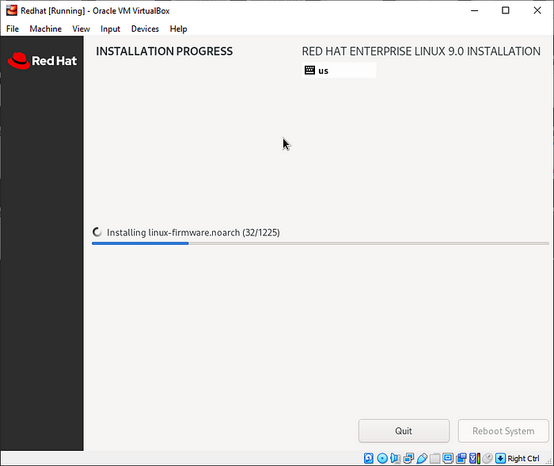

RHEL 9 Installation

**Red Hat Enterprise Linux 9** Installation is completed.

At this point, it is safe to remove your installation media, or in this case, **unmount** the ISO image file. During the reboot process, select the first entry and hit ENTER.

Click **Reboot System**.

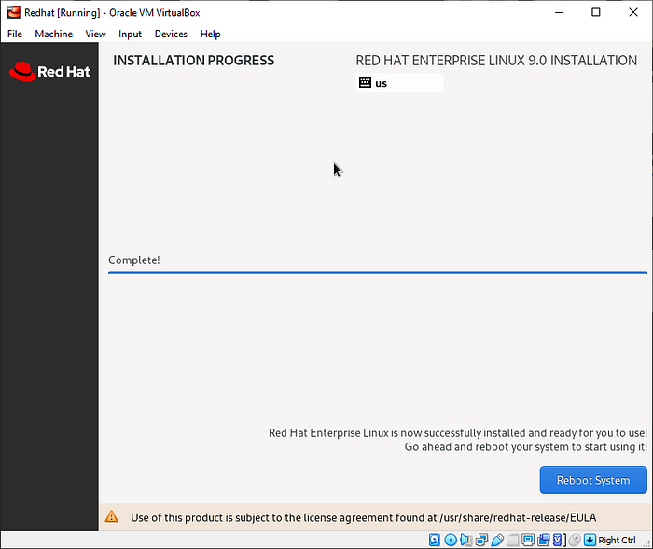

RHEL 9 Installation Completed

Now, Red Hat Enterprise Linux 9 **GRUB file** show here.

Press **Enter.**

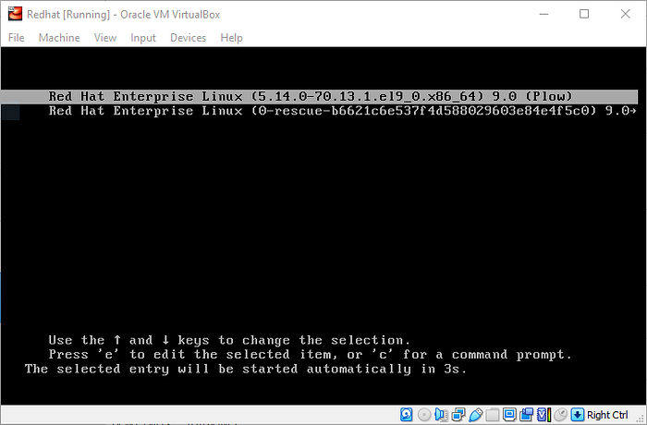

RHEL 9 GRUB Menu

Now, Red Hat Enterprise Linux 9 login page show here.

Press **Enter**.

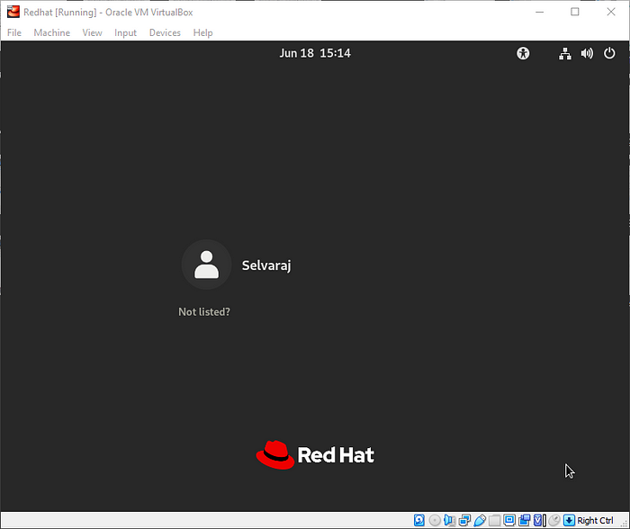

RHEL 9 Login

In the Red Hat Enterprise Linux 9 login screen. Enter your user password.

Press **Enter.**

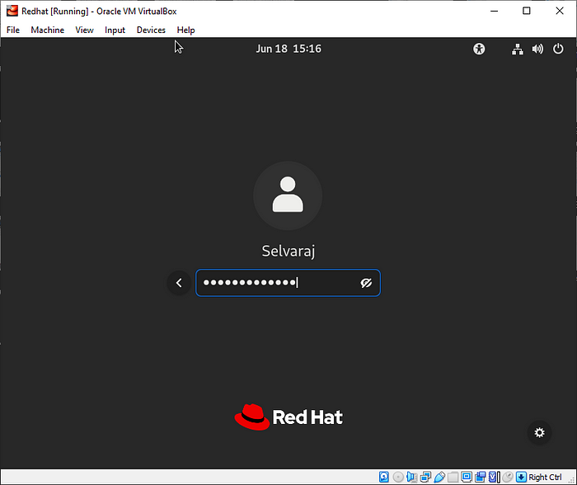

RHEL 9 Login

Now, Red Hat Enterprise Linux 9 logged successfully.

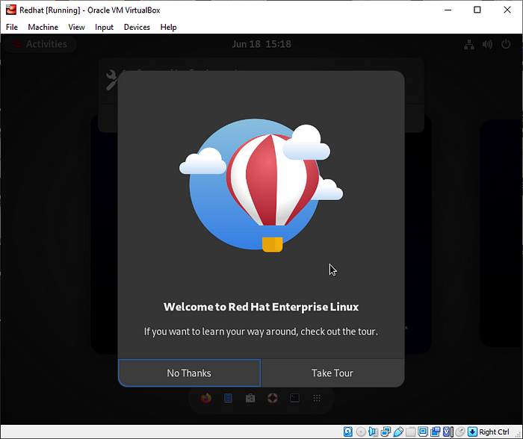

RHEL 9 Tour

Now, you can explore Red Hat Enterprise Linux 9.

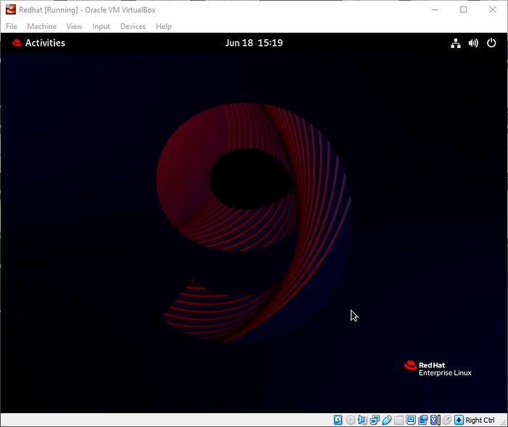

RHEL 9 Desktop

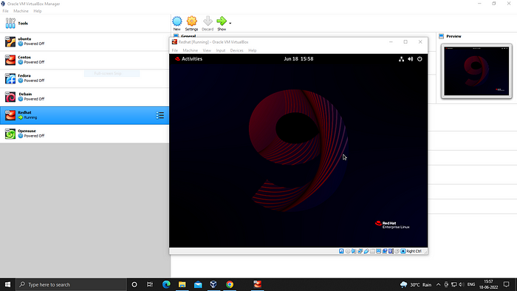

RHEL 9 Desktop

Check, Red Hat Enterprise Linux 9 version.

Use below command in terminal.

cat /etc/os-release

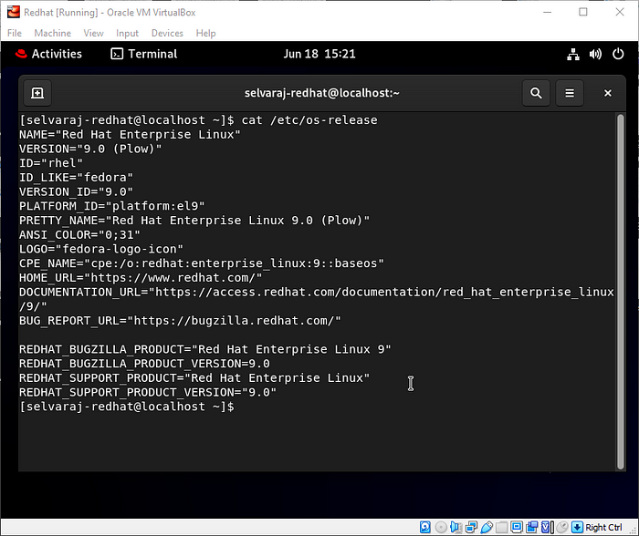

RHEL 9 Details

Finally, Red Hat Enterprise Linux 9 has successfully installed.

**Step 5:- Enable and Disable Red Hat Subscription on RHEL 9**

**Prerequisites**

**Register and Enable Red Hat subscription**

Once you have Red Hat Enterprise Linux installed, you must **register** **and** **enable** **Red Hat Subscription** to install any package on your system.

Open terminal and enter the below command.to register and enable RedHat Subscription.

subscription-manager register --auto-attach

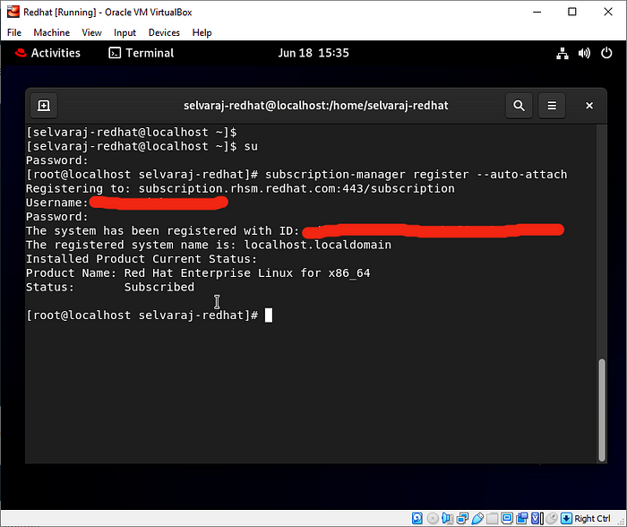

Enable Red Hat Subscription on RHEL 9

**Update the RHEL 9**

Now, you can **update** the Red Hat Enterprise Linux 9.

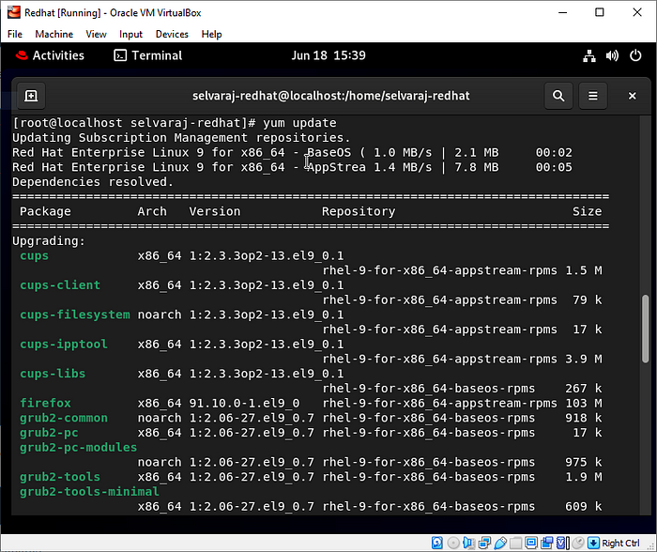

Update RHEL 9 System

**Verifying Subscription**

List of attached subscription can be verified by running the below command.

subscription-manager list

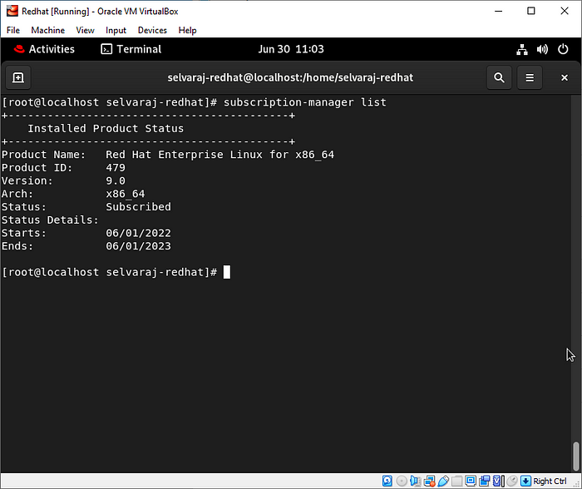

RedHat Subscription Manager List

**Un-registering a system**

**Remove** all subscriptions from Red Hat to run the below command.

subscription-manager remove --all

https://miro.medium.com/v2/resize:fit:700/1*ku5sncrBOekKNZyanz9GDQ.png

Remove RedHat Subscription on RHEL 9

To unregister the system from the Red Hat to run the below command.

subscription-manager unregister

https://miro.medium.com/v2/resize:fit:700/1*gGNYwy5vkXywVmuMgR7i0A.png

Unregister Red Hat Subscription on RHEL 9

To remove all local data from the system from the Red Hat to run the below command.

subscription-manager clean

https://miro.medium.com/v2/resize:fit:700/1*WtGsinvprBLoNjrXzN_REQ.png

Clean RedHat Subscription on RHEL 9

Check, Red Hat Enterprise Linux 9 details using ***neofetch***command(Optional).

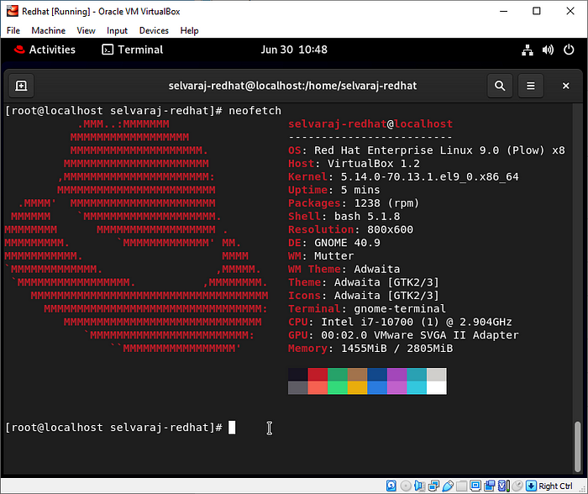

RHEL 9 Details in Neofetch

Red Hat Enterprise Linux 9 in VirtualBox.

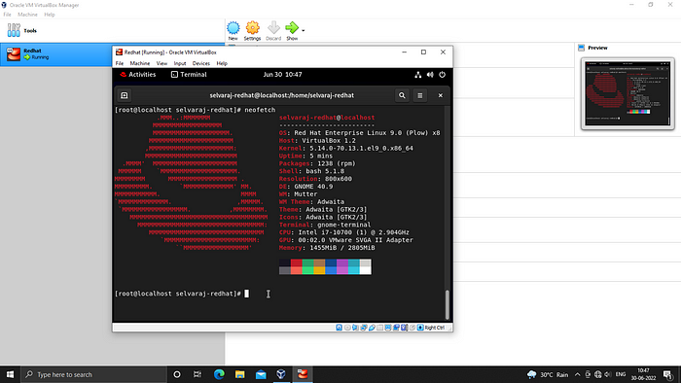

RHEL 9 Desktop

**Conclusion**

In this blog, I Shown you to **Install Red Hat Enterprise Linux 9 in VirtualBox**and**Enable and Disable Red Hat Subscription** on **Red Hat Enterprise Linux 9.**